Lab 4

Microprocessors and Microcontrollers

Alon Spinner,

Noam Berkovich,

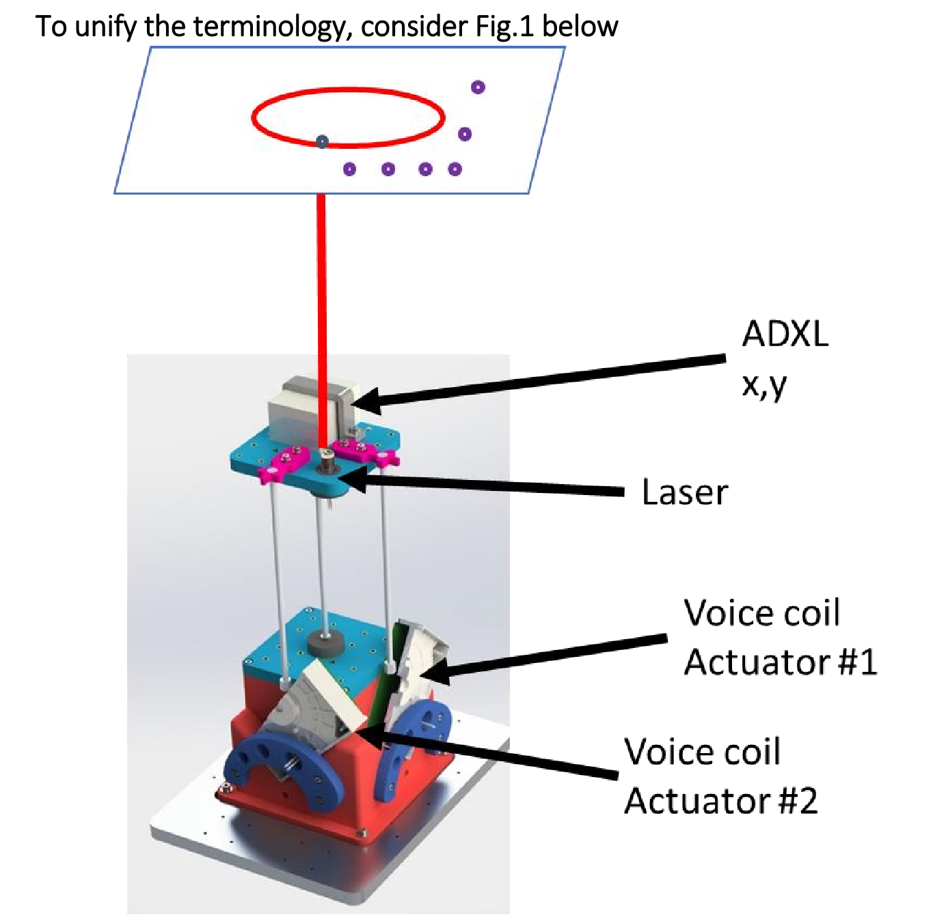

Email:

[AlonSpinner@campus.technion.ac.il](mailto:AlonSpinner@campus.technion.ac.il)

**Berkovich@campus.technion.ac.il**

# Assignment number 1

Open directory “…\Q1and2\Manual_UART_xy_wiggler”

Run the Matlab GUI file called “Lab4GUI_1.m” (in said directory)

The following figure will pop up.

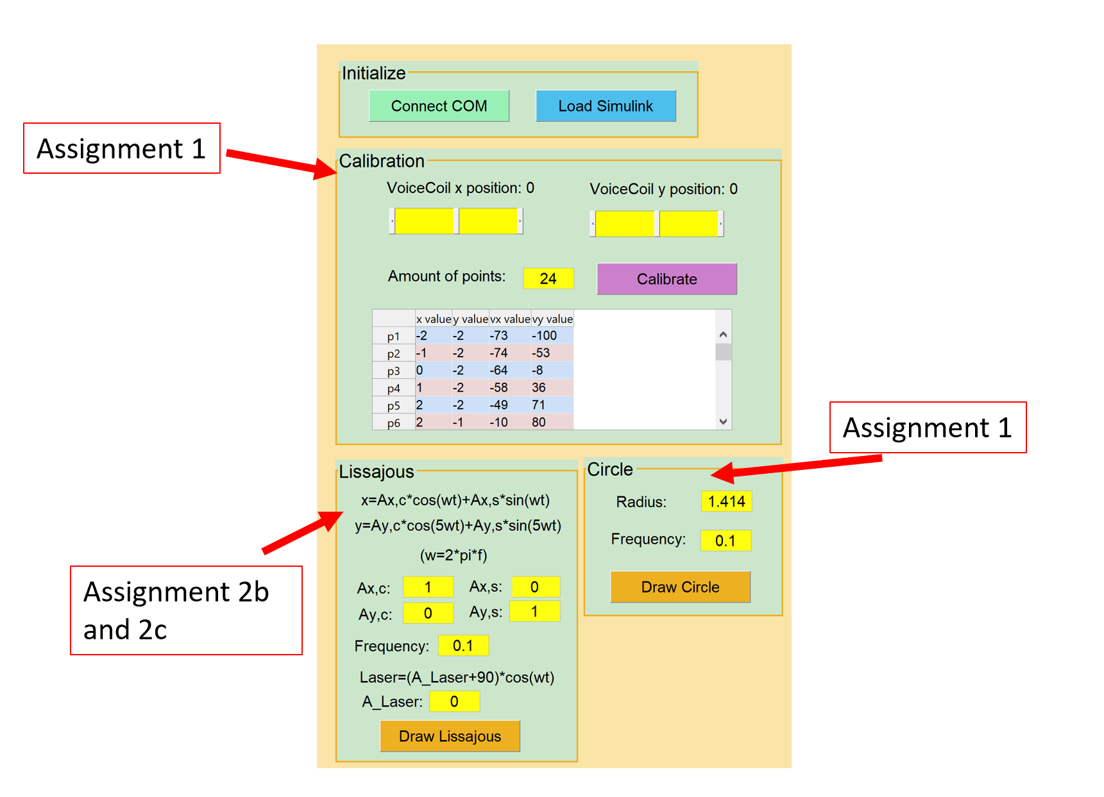

Default values for calibration and curve drawing were sent as soon as the Simulink model was loaded (notice that you load the model via the GUI).

## Calibration

The model suggested between the laser position on the paper sheet $(x,y)$ and the duty cycle given to the motor’s $PWM$ signal $(v_{x},v_{y})$ follows:

$$v_{x}=a_{1,0}x+a_{0,1}y+a_{2,0}x^{2}+a_{0,2}y^{2}+a_{1,1}xy$$

$$v_{y}=b_{1,0}x+b_{0,1}y+b_{2,0}x^{2}+b_{0,2}y^{2}+b_{1,1}xy$$

Or in vector notation

$$v_{x}=\left[x,y,x^{2},y^{2},xy\right]⋅a^{T}$$

$$v_{y}=\left[x,y,x^{2},y^{2},xy\right]⋅b^{T}$$

Calibrating the system is the same as computing “good” vectors $a$ and $b$. We accomplished this using least squares and a circular observation path to avoid hysteresis drift as much as possible:

* Solving Least squares:

Assuming the model is correct the following must hold true

$$Aa^{T}=v_{x}$$

$$Ab^{T}=v_{y}$$

$A$ is the observation matrix containing data from observations $1...n$

$$A=\left[\begin{matrix}x_{1} & y_{1} & x_{1}^{2} & y_{1}^{2} & x_{1}y_{1} \\ x_{2} & y_{2} & x_{2}^{2} & y_{2}^{2} & x_{2}y_{2} \\ & & & & \\ x_{n} & y_{n} & x_{n}^{2} & y_{n}^{2} & x_{n}y_{n}\end{matrix}\right]$$

Using Moore-Penrose pseudo inverse method for solving least squares with linear independent rows:

$$A^{+}=A^{T}{\left(AA^{T}\right)}^{-1}$$

$$a_{lsqr}^{T}=A^{+}v_{x}$$

$$b_{lsqr}^{T}=A^{+}v_{y}$$

*in practice, we did not use the Moore-Penrose method but had let Matlab compute the least squares for us using the “\” operator.

* Circular observation path:

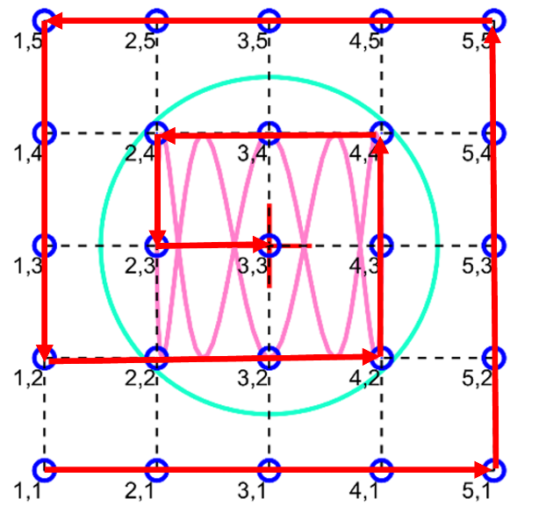

## Drawing Circle

Frequency and Radius of the circle are sent from the GUI to the STM using UART communication.

The frequency and radius are than used to compute the laser position over time:

$$r(t)=r[\cos\left(2πft\right),\sin\left(2πft\right)]$$

With the $Cosine$ and $Sine$ signals being generated on the STM.

Once $r(t_{0})$ is computed we pass it through the calibration to obtain $v_{x},v_{y}$ which in turn are sent to the motors.

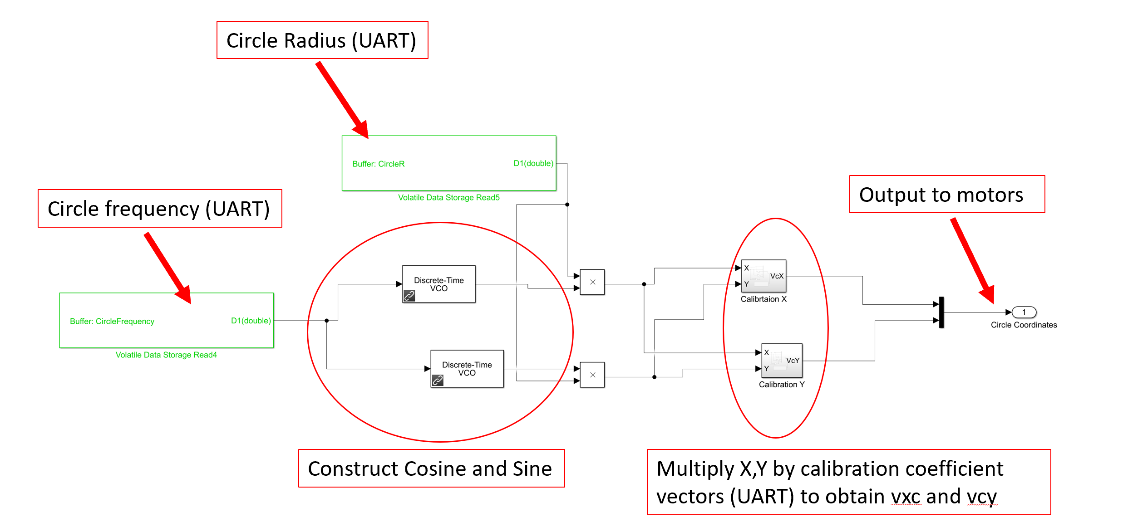

Result:



# Assignment number 2

This assignment was broken up to two different Simulink codes.  
Part a: “…\Q1and2\Manual_UART_xy_wiggler\uart_xy_wiggler.slx”  
Part b-c: “…\Q1and2\record_steps_wiggler_adxl\ADXL_recorder_fast1.slx”

## Part a

Open “…\Q1and2\record_steps_wiggler_adxl\ADXL_recorder_fast1.slx” and build it via the Simulink.

Then open “…\Q1and2\record_steps_wiggler_adxl\test_recorder_adxl.m” and run it.

You will be asked to specify magnitudes and frequencies of the motor square waves.

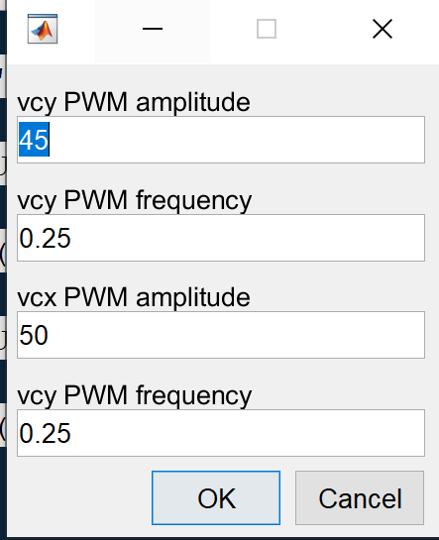

the parameters are sent to the STM where the signals are generated and filtered

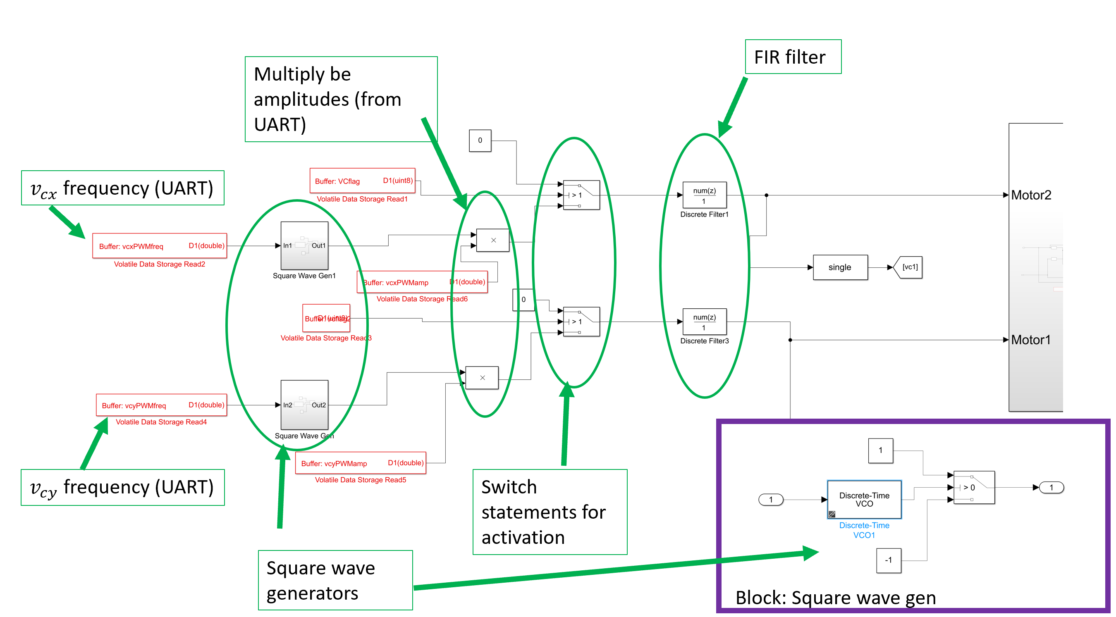

The filter is a FIR s-curve filter designed as follows:

$$u_{step response =}\int_{0}^{t}{h\left(τ\right)dτ }$$

Where $h(t)$ is the shock response.   
for the required s-curve is of the shape

$$u_{step response}=\frac{1}{2}\left(1-\cos\left(\frac{πt}{t_{f}}\right)\right)$$

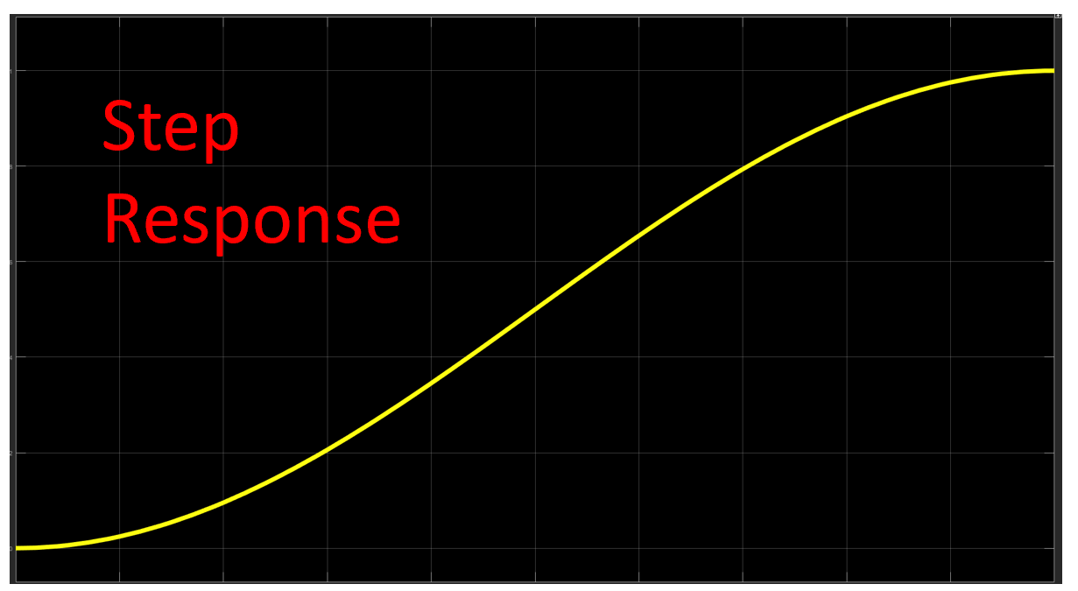

The shock response would be

$$u_{shock response}=\frac{∂u_{step response}}{∂t}=\frac{1}{2}\frac{π}{t_{f}}\sin\left(\frac{πt}{t_{f}}\right)$$

Given that we want the signal to reach the input step’s value in $t_{f}$ seconds,  
The FIR filter numerator would be $u_{shock response}$ and the denominator $1$.  
We chose $t_{f}=0.5[s]$  
The sampling rate defined in the Simulink is $1[ms]$ and so numerator vector we entered follows: 0.5*sin(pi*[0:500]/500)*(pi/500).

Result for symmetric 80 PWM with 0.5Hz frequency:

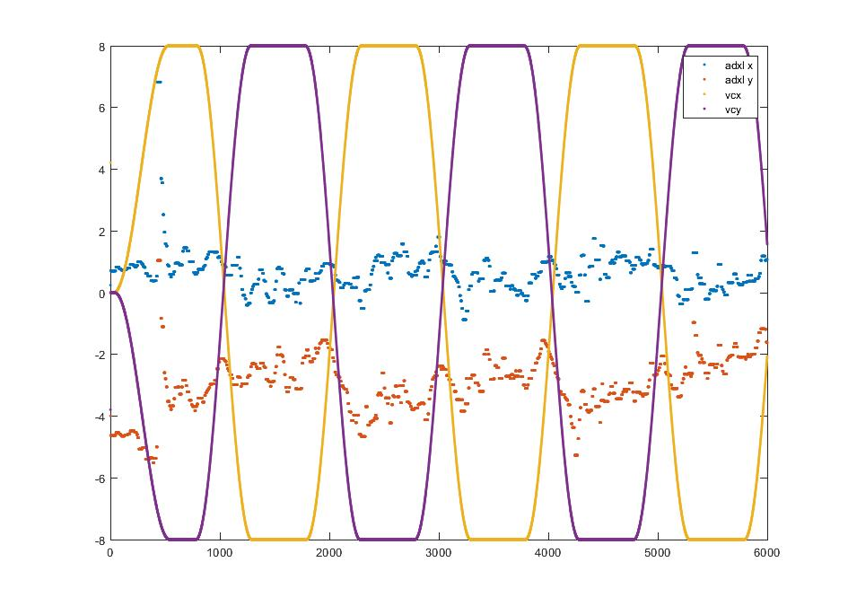

# Part b+c

Returning to the GUI shown in assignment 1 (“…\Q1and2\Manual_UART_xy_wiggler\Lab4GUI_1.m”)

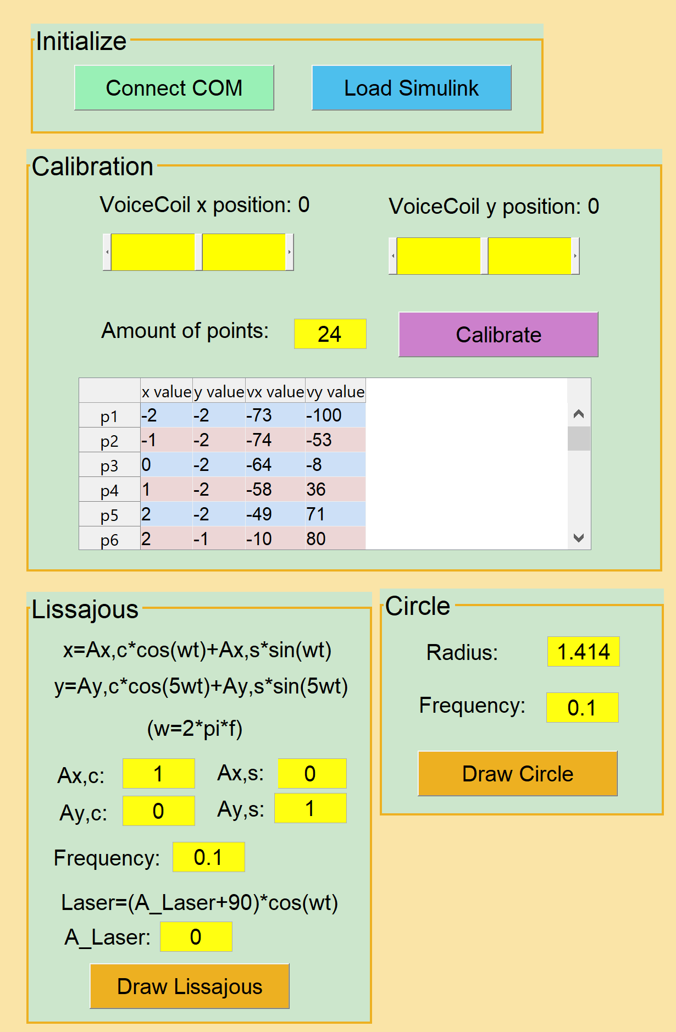

To draw Lissajous’s curves all the parameters can be defined in the GUI (sent through UART).  
Note: the Laser is bright between $PWM$ values of $0-95$, starts to fade in higher levels until it shuts down completely at $PWM=100$. “laser” in the GUI ~ $PWM_{laser}$

The Lissajou’s Simulink block is very similar to the circle one from assignment one:

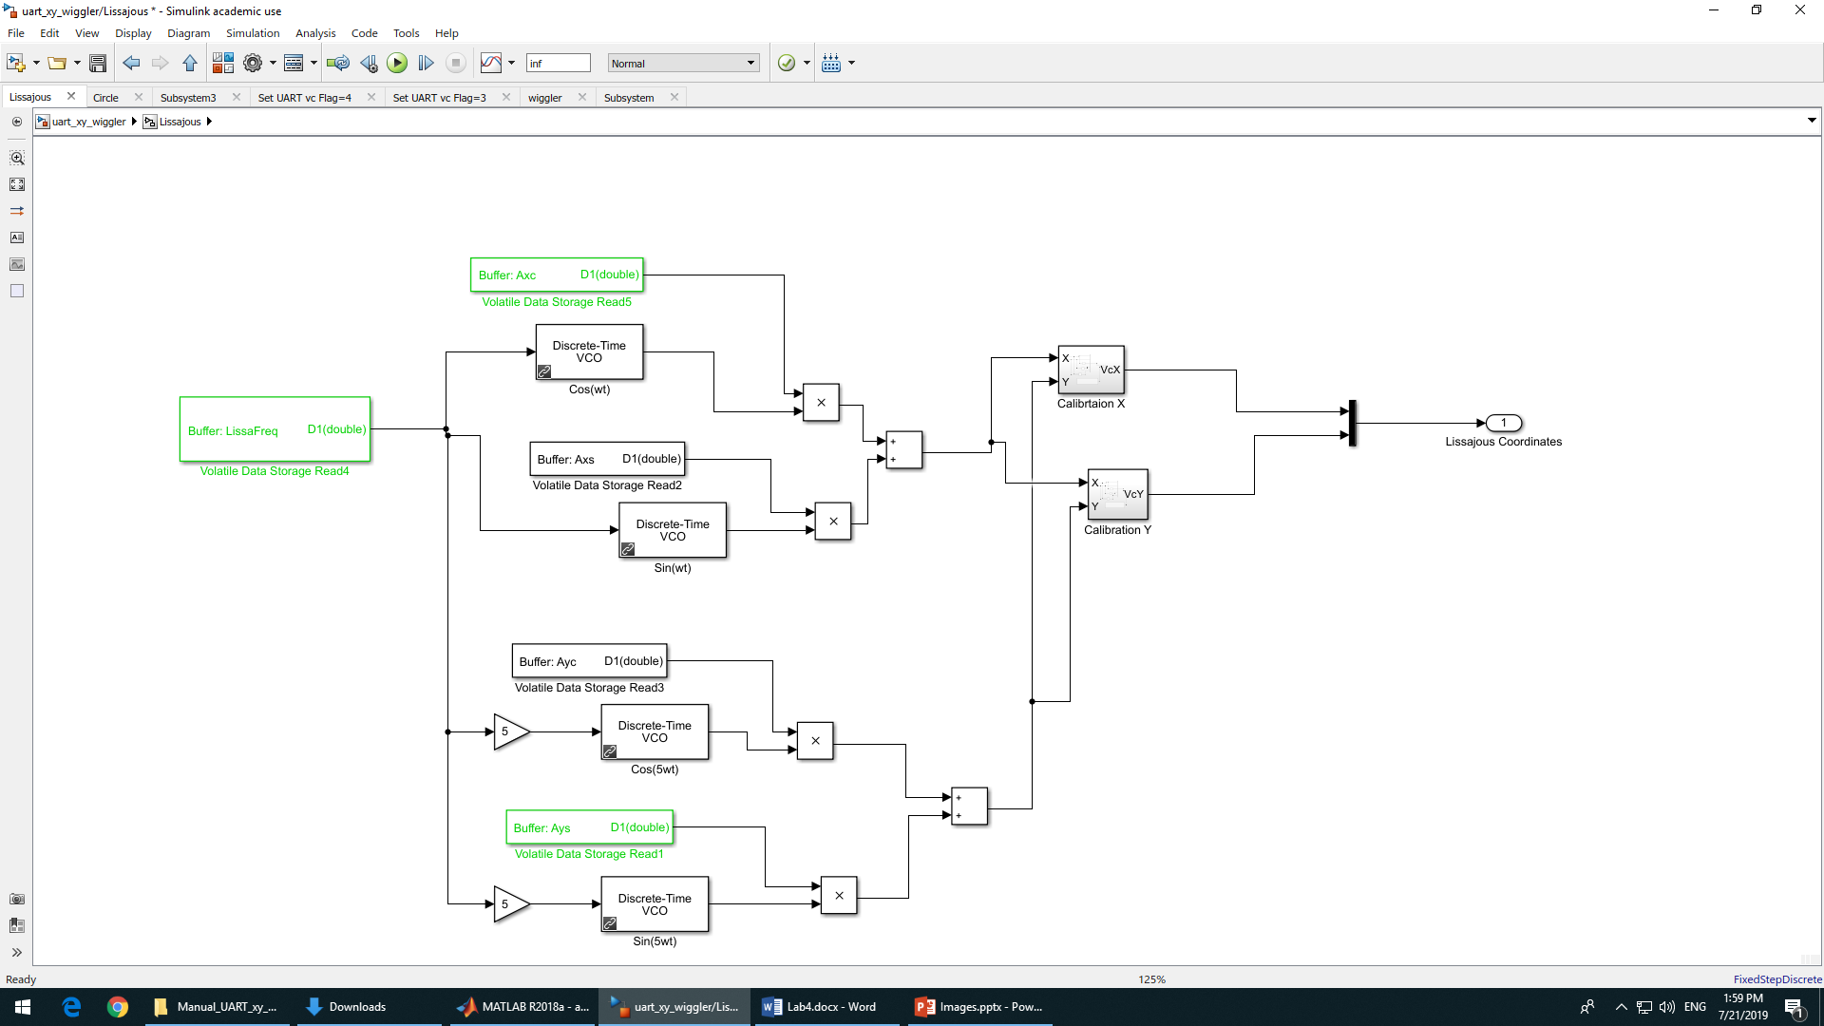

Result:





